**LAB#7**

**Task 6** - Write a program that takes a positive integer ( x<9999) as input and expresses the number in words. Use do-while loop

Source code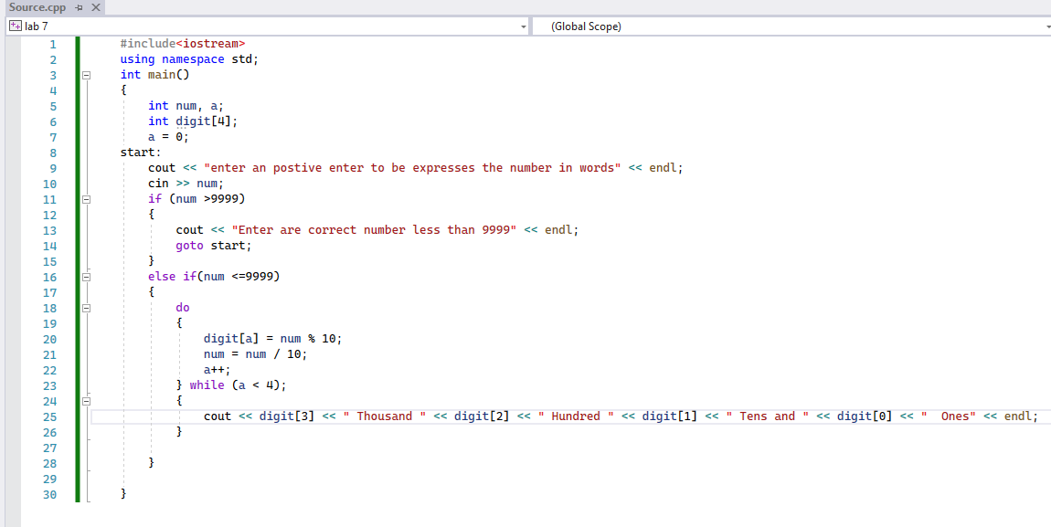

Output

